**Project Documentation**

Beka Bekeri -

Álvaro Guerrero del Pozo

Fernando Vallejo Banegas

Course 2017/2018

Index

1. Description

1. Decisions taken
2. User manual
3. Testing
4. Code

**1-Description:**

We have to develop a program to distribute sand in a given terrain, represented as an array. The responsibility for doing so is for a truck, whose position will be represented as a tuple (X,Y), inside the field. The objective is to reach an amount of sand in every cell. The constraints are:

-The truck moves sand from the cell it is.

-The truck can only move sand to the adjacent cells (N, S, E, W)

-There is a maximum of sand in every cell.

-The truck must not move sand if the sand of the current cell is less than the objective.

At the end of the execution, the program generates a List of possible actions, and uses one of them randomly to generate a new state.

**2 - Decisions taken**

**For tasks 1 and 2:**

-We have used java because our understanding of the language is greater than in the case of other languages(like python, c, c++...)

-Each successor has a reference to its father, which in the case of the root (initial state) points to null. So, the successors are stored in a tree, although we do not use java implementation for trees.

-The frontier has been implemented as a PriorityQueue. It provides us the necessary tools for our problem: we can add nodes in increasing order of their value (which is random for now) and, more important, we can extract the peek of the frontier with a complexity of O(1). Later we will provide some experiments regarding times and amount of nodes it can store.

-For simplicity, the actions are stored in a List. It provides the necessary tools, add, and get actions.

**Changes in task 3:**

We want to reduce the amount of memory used, so, we changed the integers that don’t need to be bigger that 127 from integers (int = 32 bits) to java bytes (byte = 8 bits). But, as we cannot add bytes, we need to use a casting for that. So, we cuestioned if the casting would delay the overall execution of the program, and therefore, our attempt of improvement was going to fail. So we did the next test:

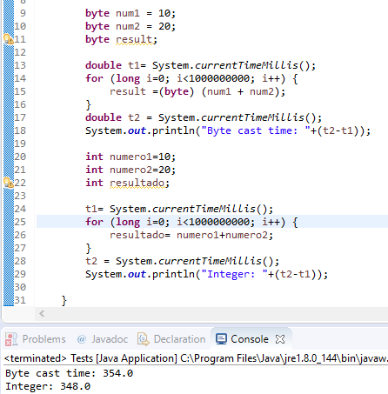

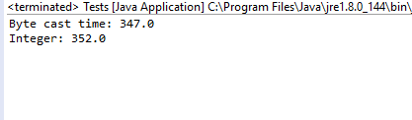

With this result, that shows that casting won’t have any negative effect, we can now use bytes, reducing the memory used by some of the variables of every state by ¼.

**3 - User manual**

**Tasks 1 and 2:**

The program starts asking the user what he/she wants to do. For now, only two options are available: read data from a file, and exit from the program and terminate execution **(Image 1)**. If the first option is chosen, the user will be asked to provide the name of the file **(Image 2)**. If the file is found, and no other errors happen*(e.g the truck is out of field bounds), the program will start its functioning **(Image 3)**. If the goal is achieved, the user will be asked if he/she wants to save the final result in a file, and the name.

Referring to files, remember that there are two options of introducing the name: either the file is (or is going to be created while writing) in the parent directory of /src, and therefore we can write just the name of the file (e.g example.txt); or the absolute path is introduced (e.g C:\Users\Myself\Documents\myfile.txt).

No errors are controlled while writing. The user will just receive a generic message. For this reason is recommended to use the first way of introducing the file name, <name>.<extension>, so we avoid permission problems. Also, take into account that if the file with the given name already exists, it will be replaced.

In case of error, the program will try to create the file “log.txt” with the information.

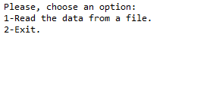

**Image 1**

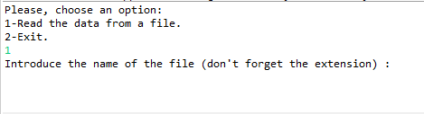

**Image 2**

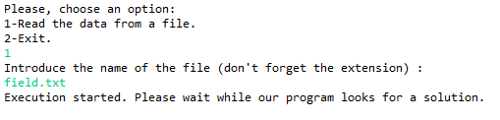

**Image 3**

*\*In the case of errors while reading the file, the user may receive a message giving further information about the problem.*

**Task 3:**

Now, the program asks for the maximum depth that the algorithm can expand after the name of the file to be read. After introducing that, the user is asked for what strategy he wants the algorithm to use, between BFS, DFS, IDS or UCS, as can be seen in the next image. Note that all of them are limited by the depth introduced previously (therefore, DFS is in fact DLS).

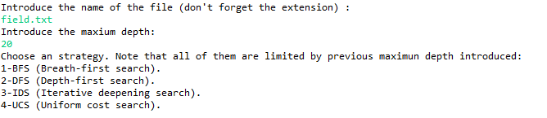

**4 - Testing**

To select a data structure to implement the frontier we had to make some testings with several kinds of data structure, always taking into account that those data structures should offer a way to order the states by a key value, which for this testings is set to random.

The data structures we have chosen to test their performance is:

1. LinkedList
2. PriorityQueue
3. SortedSet

The first thing we need to test is the speed of each data structure inserting states, to do that we can define an algorithm in which the computer tests inserting different quantities of states.

The quantities for which the data structures are going to be tested are:



And the algorithm to insert the nodes is:

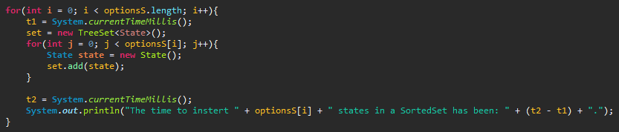

These are the results we obtained:

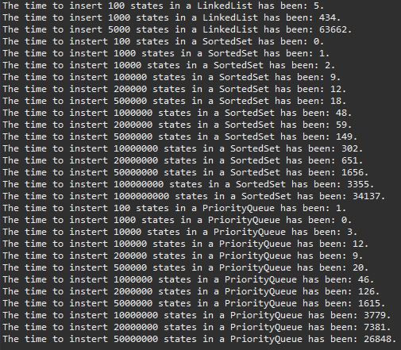

By looking at this results it can be seen that by far the best option are the SortedSets but this is just inserting Nodes, the problem is that if we need to use several operation on our data structure we need to take care of the cost of the other operations, such as retrieving data, etc.

There is something more to be taken into account: extraction of a node in the frontier. In this case, the PriorityQueue will always be faster, as it only has to access to the first element, and therefore, having a complexity of O(1), while the Set, that represents the mathematical meaning of Set, and therefore isn’t really sorted (it just can be used like it was, it’s transparent to the programmer). This means that getting an especific element of the set (the “first” one according to our criteria) will take O(log n) time, as it has to be found using Binary Search. Because this reason, which is a language specific problem (Java), our program will be using PriorityQueues.

Once that the priorityQueue has been selected we have to implement the method compareTo:

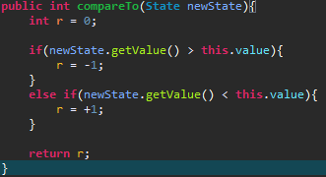

*Note that in Task 3 and on, a Node is used as argument.*

However now lets review a comparision of both the SortedSet and the PriorityQueue in form of bar charts:

1. **SortedSet**

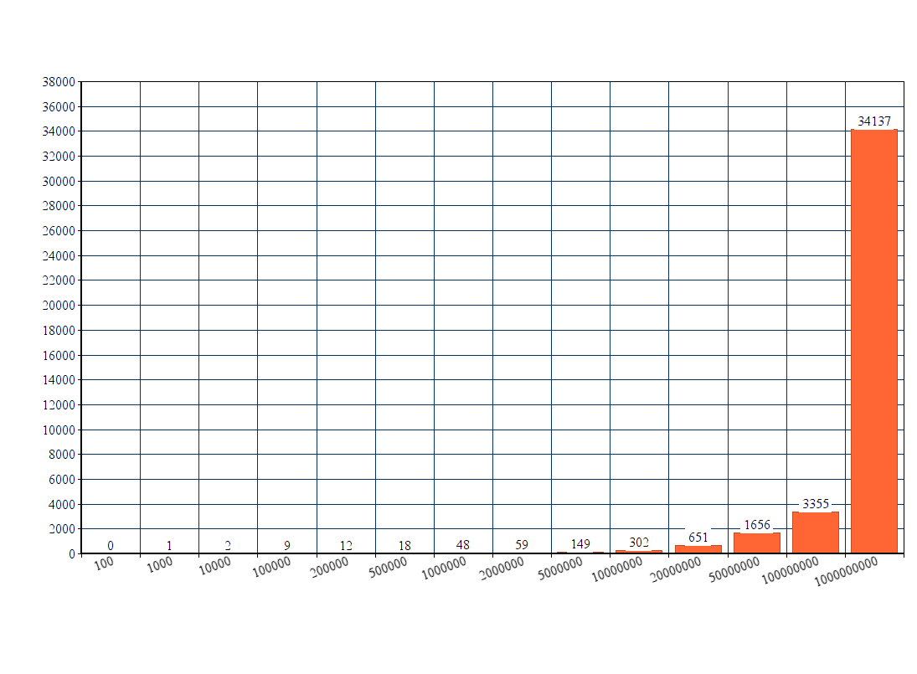

As we can see here the sortedSets behave properly with almost any time needed under the 10.000.000 states which is quite a good performance.

**2. PriorityQueue:**

In this bar chart we can see the behaviour of the priority queue while trying to insert a specific number of states. In this case, since the 2.000.000 states, the differences tend to grow exponentially which is not desirable but in our case we do not need that amount of states.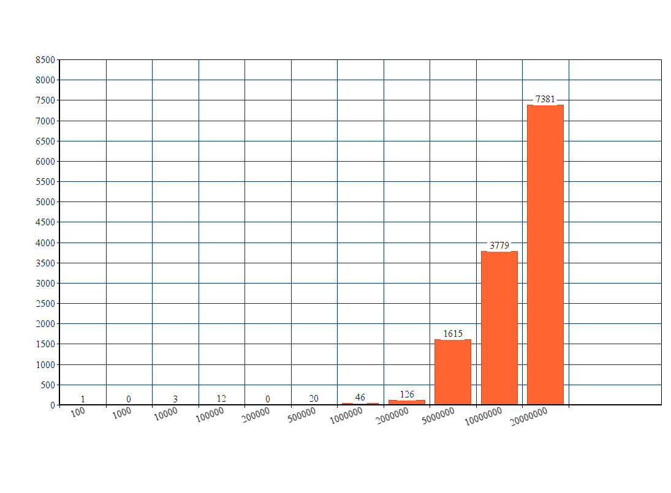

**5 - Code**

**Structure of the source code:**

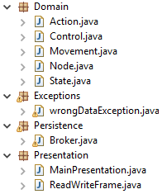

As can be seen in the image above we have developed the application using the multitier architecture.

In our case, a three-tier architecture, following the above criteria:

* The Presentation tier has the functionality of interacting with the user (i.e. asking for input data, showing error messages). It includes the classes:
  + MainPresentation: Class that contains the main, and therefore, the first executed. Interacts with the user for showing/asking the information required for the execution of the program.
  + ReadWriteFrame: Class in charged of showing the user differents messaged generated when an error happens while reading or writing. Also asks for the name of files.
* The Domain tier is the tier in which the main functionalities of the program, the ones related with the definition of the problem, are implemented. It includes the classes:
  + Action: Class used to create objects “Action”, and that implements its methods. Used to store the amount of sand moved in each direction, alongside with the movement of the tractor, stored as a pointer to a Movement.
  + Control: Class that implements the core of this program’s functionality, discussed later.
  + Movement: Class used to create objects “Movement”, and that implements its methods.
  + Node: Class used to create objects “Node”. Contains a depth, a value (used to find the solution, depend on the strategy), the cost (to reach that state), pointers to the father node, the applied action to reach that node, and the state that this node contains.
  + State: Class used to create objects “State”. Contains information related to the definition of the problem: the state of the field (represented as an array), and the position of the truck.
* The Persistence tier is in charged of reading and writing of/to files. The only class in this tier is the Broker, that implements that functionalities.

Alongside with this three tiers, there is also a package “Exceptions”. It only includes the class wrongDataException. This exception is thrown when at the time of reading there is any error with the given file (i.e letters introduced, information not consistent, etc). Thrown by the broker.

**Important parts of the code:**

**Tasks 1 and 2:**

1. GenerateActions:

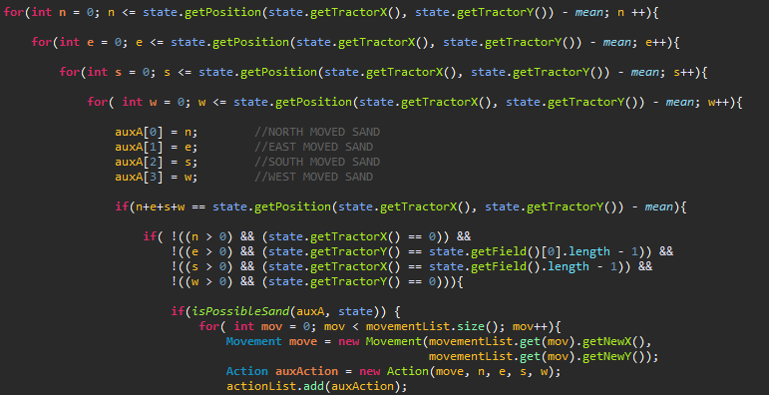

This method is made to obtain all the combinations of the actions with a 4 nested for loops that try all the possibilities from 0 to the maximum quantity of sand that can be moved from that positions which is (PositionQuntity - Mean)

Once that a combination is obtained we have to check if doing that is possible or not, to do that with the 2 if condition, we check that it doesnt move sand out of the bounds and if the total quantity moved is less than the total amount of sand that can be moved in that position.

Then just if the combination is right we create an object of the class Action, and introduce it into the actionList that we are going to return in this method.

2. GenerateMovements:

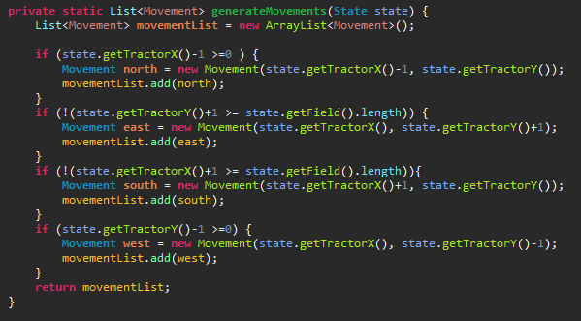

This method is made to obtain a list of Movements, a class that represents the next movement of

the tractor, so to do that we need the actual state, which contains the actual position of the tractor

and with that information we can obtain the four possible movements of the tractor (North, East,

South, West), once that those movements are created, we add to the list and that list is returned

to be mixed with actions.

3. ApplyAction:

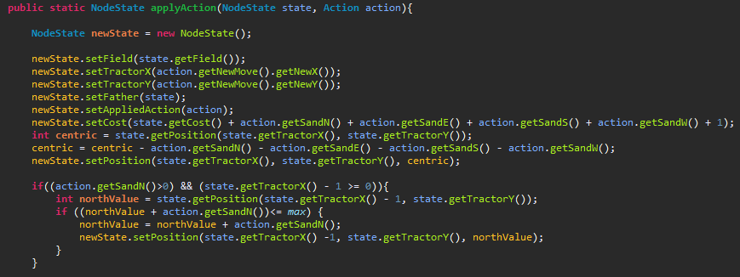

(NOTE: this method is not complete, there are another 3 if clauses that are equal than the one in the screenshot but for the

rest of the directions.)

This method is made to once that we have the whole possible actions to be applied to a state

start applying them. To do that we first have to create a new State which is going to be the

combination of the initial state and the action applied, Then we have to set the variables as the

ones of the initial state and then change the values of the fields that have been modified, these

are the steps:

1. Set the values of the tractor in the new state as the coordinates that come in the Action attribute movement.
2. Rest the sand that has been moved from the position of the tractor.
3. Set that new value to the same position but in the new state.
4. Finally, repeating this step to the four directions, find the sum of the value of the north and the sand that has been moved to the north, and setting that value in that position but in the new state.

**Task 3:**

The most important change in this task was the addition of new functional search strategies, Therefore, the most vital change is:

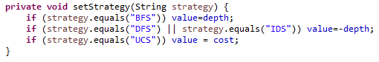

In this piece of code, we change the attribute value of a node, depending on the introduced strategy. With this new value, the frontier is correctly ordered according to the strategy.

**Code repository:**

Uploaded to: <https://github.com/BekaBekeri/Inteligentes>